Software Engineering Sprint 3

Group 9

April 28, 2021

Augur Installation guide on DigitalOcean using Ubuntu 18.04

1. Sign into a DigitalOcean account and select create Droplet. (Select the settings below).
   1. Depending on your needs you may want to select a more powerful plan.

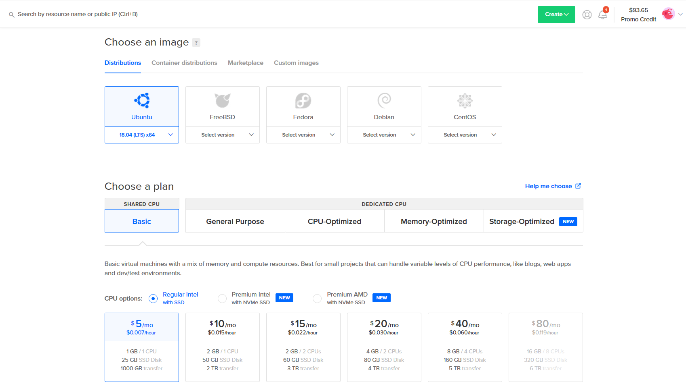

1. Once you’ve selected a pricing option, you can choose a region for your droplet, we recommend a region that is close to your area in consideration of network latency

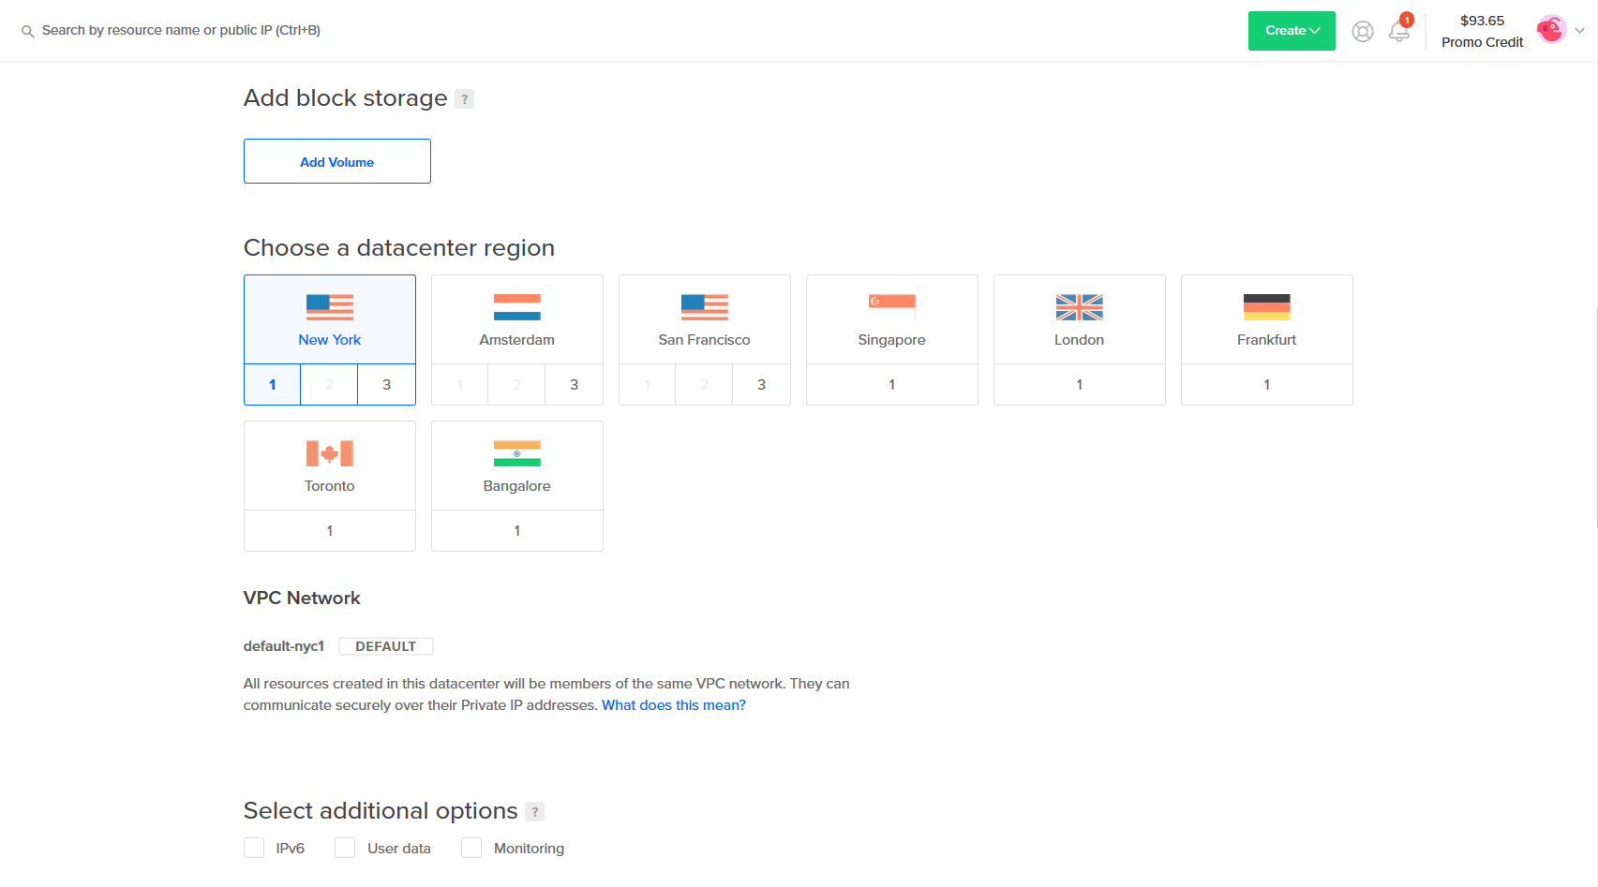

1. Select a method to connect to your droplet. For ease of use, creating a password would be optimal. For security purposes an SSH key would be a more viable long term solution.

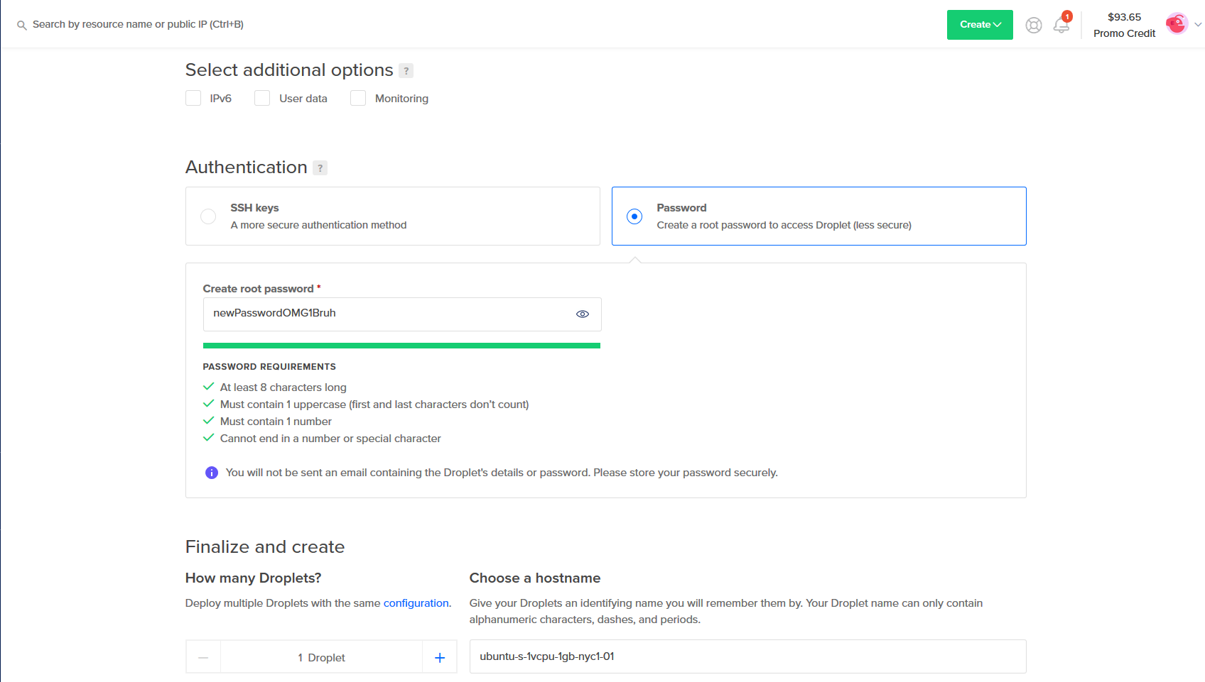

1. Finalize your droplet creation. In “Choose a Hostname” You can rename your droplet if you desire.

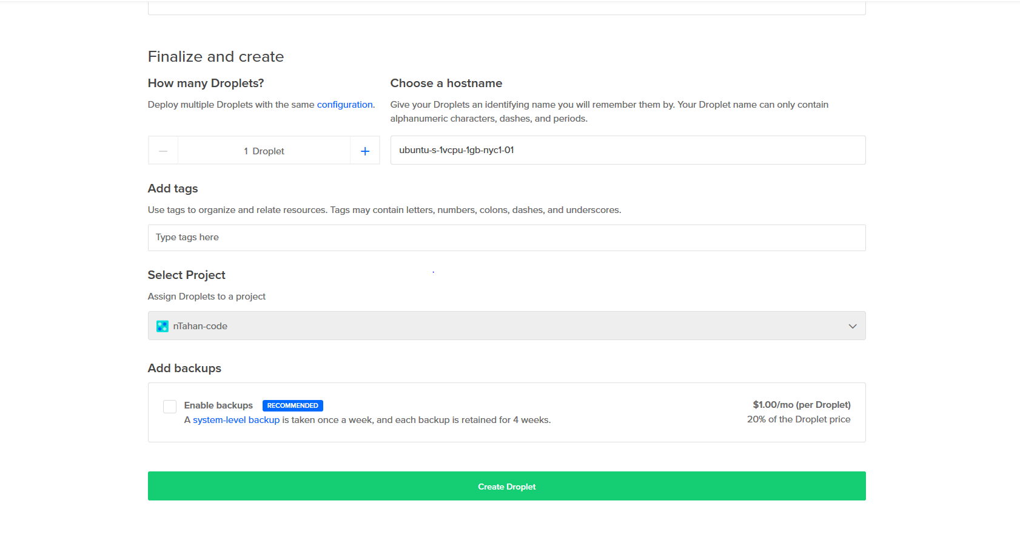

1. Select your created droplet. Below there is information about the state of the droplet and its performance. In order to connect to your droplet, copy the ipv4 address and type in terminal: ssh root@ipv4_address

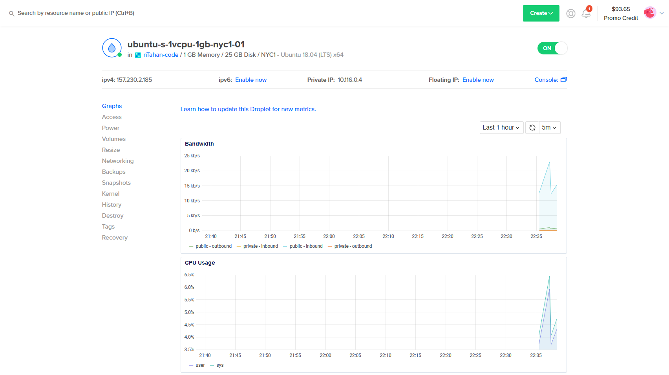

1. Type in your password that you generated.

